End User Requirements
enhanced barcode shipping module

Golden Technologies

Document Approval
Approver | Approved Date | Rejected Date | Comments

Part 1 Functionality Overview

Objectives (Why are we doing this?)
Golden has several customers that are overseas or require multiple sales orders to be shipped at the same time. They also are strictly serialized for their finished goods and as such must rely on allocation of serial numbers to shipping lines.

Business Process
The current process is to identify that a customer who requests multiple sales orders to be shipped in a single container/truck load. Those products are moved to a staging area in preparation for creating a shipment.
Serial numbers are currently written down on an excel sheet and multiple shipping documents are prepared as we currently only allow a single sales order per shipment unless using the batch processing module.
After creation of shipping documents, someone must manually allocate the serial numbers on the excel sheet from a previous step to the packing slip and if any errors are identified then the user must re-visit the staging location to locate the error.
Allocation is either based on customer specifically asking for the sales order line or by the oldest sales order line.
The desired process would be to use the barcode shipping module with enhancements:
Enhancement list:
- Select or scan a customer instead of a single sales order
- Detail grid will fill with all open sales order lines for that customer
- (retain single sales order selection as well)
- Scanning of a serial number without an associated sales order detail will allocate the serial number (qty 1) to the oldest sales order line containing that product
- (LS/SN123456)
- Scanning of a serial number with a sales order detail id will allocate the serial number (qty 1) to the specified Sales Order detail ID
- (SOD/12345/LS/SN123456)
- Error trapping to be maintained with the addition of Serial number kickback if the product for that scanned serial number is not on the list of available items to ship
- The detail list of items to be shipped will automatically be summed for the qty shipped field to enable an overall count of product to ship verification.
- The detail list of items to be shipped will support transaction launching drill back to sales order capabilities as does standard searches
- An added button to launch the Shipping document will be added to the header to allow user to quickly go to the completed shipping document to review, print documentation and add any ancillary information. Alternatively, the header tabs available on the shipping screen can be included in the barcode shipping modules header along with reports and approval buttons.

User Roles and Responsibilities
Customer will be responsible for providing reports or labeling consistent with prefixes required for barcode shipping module and modify any reports to allow accommodating multiple sales order shipments per shipping document.
Laptop or computer will be utilized to run the module and allow user to be “mobile”
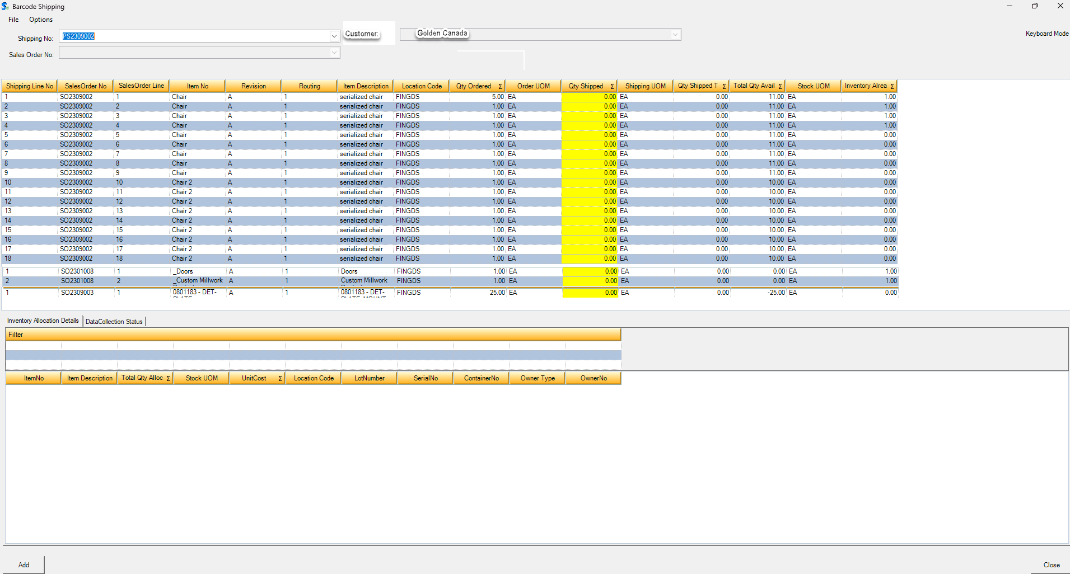
Interactions with Other Systems

Shipping
Barcode shipping module
Allocation of inventory to shipping documents

Part II – Flow Chart

Part III – Change Order Details

Date | Enhancement | Requested By | Notes | Priority | Release Status

